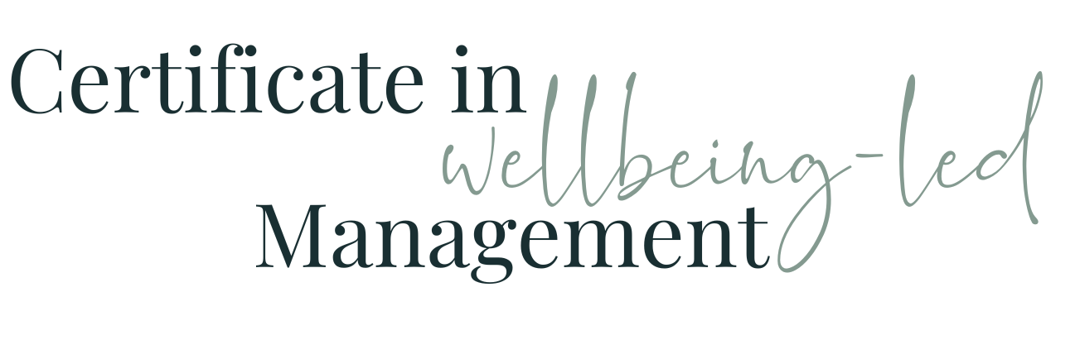

Module Five WORKBOOK

Module Five

Task One - Team

Is my team a cricket team (operate as a codependent team) or a dressage team? (operate individually, with results added together)

Task Two - As yet unidentified team(s)
Where else / who else across the organisation am I or my “team” members part of a cricket team with?
Where else / who else across the organisation am I or my “team” members part of a cricket team with?

Task Three - Team Effectiveness

Based on your current knowledge and understanding, how effective (1 - 10, 10 being amazing) would you rate each of the teams you’ve identified above as being currently? (list a separate score for each team)

Task Four - Characteristics of successful teams
Work here just on the team or teams you have managerial or leadership influence over , or that you’re a part of and want to influence

Goal oriented mindset
Does the team currently have this? To what level (1 - 10)
How could it be increased / improved?

Commitment to their roles
Does the team currently have this? To what level (1 - 10)
How could it be increased / improved?

Open to listening
Does the team currently have this? To what level (1 - 10)
How could it be increased / improved?

Learn from each other
Does the team currently have this? To what level (1 - 10)
How could it be increased / improved?

Diverse perspectives and experiences
Does the team currently have this? To what level (1 - 10)
How could it be increased / improved?

Shared culture
Does the team currently have this? To what level (1 - 10)
How could it be increased / improved?

Responsibility & Accountability
Does the team currently have this? To what level (1 - 10)
How could it be increased / improved?

Clear Communication
Does the team currently have this? To what level (1 - 10)
How could it be increased / improved?

Focus on, and understanding of, the vision
Does the team currently have this? To what level (1 - 10)
How could it be increased / improved?

Values trust & authenticity
Does the team currently have this? To what level (1 - 10)
How could it be increased / improved?

Offer each other support
Does the team currently have this? To what level (1 - 10)
How could it be increased / improved?

Happy to challenge and disagree
Does the team currently have this? To what level (1 - 10)
How could it be increased / improved?

Is organised and has good processes
Does the team currently have this? To what level (1 - 10)
How could it be increased / improved?

See “opportunities to learn” not failures
Does the team currently have this? To what level (1 - 10)
How could it be increased / improved?

Celebrate and share success
Does the team currently have this? To what level (1 - 10)
How could it be increased / improved?

Has an effective leader
Does the team currently have this? To what level (1 - 10)
How could it be increased / improved?

Has Fun
Does the team currently have this? To what level (1 - 10)
How could it be increased / improved?

Task Five - Reasons Teams Fail

Do you currently perceive failures in any of these areas?
Environmental Influences
Currently a concern? To what level (1 - 10: 1 not much concern, 10 - huge concern)
How could it be improved?

Goals
Currently a concern? To what level (1 - 10: 1 not much concern, 10 - huge concern)
How could it be improved?

Roles
Currently a concern? To what level (1 - 10: 1 not much concern, 10 - huge concern)
How could it be improved?

Processes
Currently a concern? To what level (1 - 10: 1 not much concern, 10 - huge concern)
How could it be improved?

Relationships
Currently a concern? To what level (1 - 10: 1 not much concern, 10 - huge concern)
How could it be improved?

Task Seven - Steps to better teams

Where do you see you could inject or improve in these areas?

Team First
Current good points
Quick Wins
Longer term improvements

Discuss & Consult

Current good points
Quick Wins
Longer term improvements

Avoid Criticism
Current good points
Quick Wins
Longer term improvements

Uphold Transparency
Current good points
Quick Wins
Longer term improvements

Manager Responsibility
Current good points
Quick Wins
Longer term improvements

Avoid & Diffuse Conflict
Current good points
Quick Wins
Longer term improvements

Reward & Recognition
Current good points
Quick Wins
Longer term improvements

Task Eight - Extra if you want it (slides in thinkific)
Team Effectiveness Models

Do you think one or more of these could be useful to you?
Which would you start with?
Why?
How would you use it?

Task Nine - Module Five Summary

What seem the most significant elements of this module to you as an individual?
What seem the most significant elements of this module to you as a manager?
What insights have you gained into the behaviours of your colleagues at work?
How will what you’ve learned help you in understanding and managing the members of your team?

Questions

What questions do I have from this module that I need to note down to ask?

