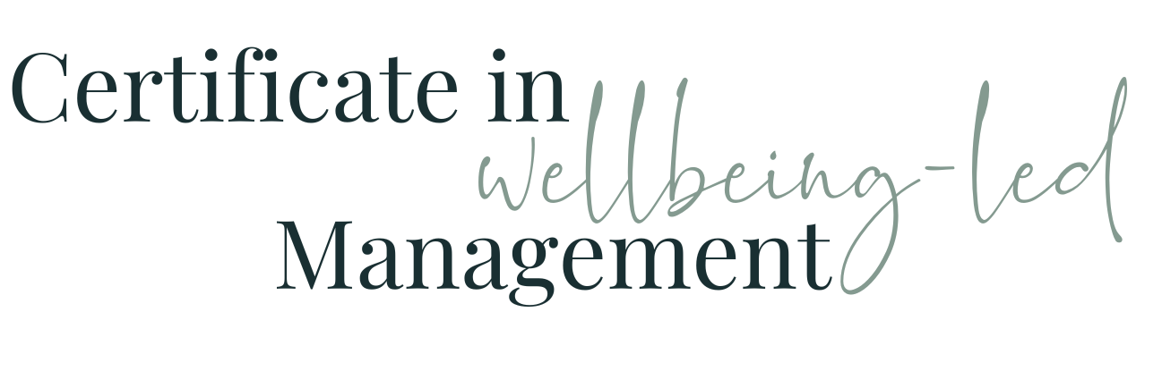

Module Four WORKBOOK

Module Four - Team Roles & Relationships

Task One - Who at work do I have a good relationship with?

More senior than me
- Same seniority as me
- In my team

Task Two - What is it about that relationship that makes it good?
Person named in a)
Person named in b)
Person named in c)

Task Three - Who do I not have a good relationship with?

More senior than me
- Same seniority as me
- In my team

Task Four - What is it about that relationship that makes it not good?
Person named in a)
Person named in b)
Person named in c)

Task Five - Interdependencies
Which colleagues are you reliant on for you to do elements of your specific role and what do you rely on them for?
Which colleagues are reliant on you to do elements of their specific role and what do they rely on you for?
Which colleagues are your team reliant on for them to do elements of their specific roles and what do they rely on them for?
Which colleagues are reliant on your team to do elements of their specific roles and what do they rely on them for?
How well are those interdependencies articulated and understood currently?
What, if any, are the challenges to these interdependencies currently?
How could they be improved?
How well are the broader interdependencies across your organisation articulated and understood?
Is there a sense of shared purpose and responsibility? How could there be?

Task Six - Team Roles

1) Plant
Who?
Positive Impact
Negative Impact

2) Resource Investigator
Who?
Positive Impact
Negative Impact

3) Co-ordinator
Who?
Positive Impact
Negative Impact

4) Shaper
Who?
Positive Impact
Negative Impact

5) Monitor Evaluator
Who?
Positive Impact
Negative Impact

6) Teamworker
Who?
Positive Impact
Negative Impact

7) Implementer
Who?
Positive Impact
Negative Impact

8) Completer FInisher
Who?
Positive Impact
Negative Impact

9) Specialist
Who?
Positive Impact
Negative Impact

Task Seven - Team Role Relationships

You and your Manager
Your Role
Their Role
How can you use this knowledge to bring about improvement?

You and colleagues
Your Role
Their Roles
How can you use this knowledge to bring about improvement?

You and your team
Your Role
Their Roles
How can you use this knowledge to bring about improvement?

Task Eight - Ideal Manager / Employee Relationship

Care personally, but not friendship
Do I get this from my boss? (How could I improve it?)
Do my team get this from me? (How could I improve it?)

Frequent guidance
Do I get this from my boss? (How could I improve it?)
Do my team get this from me? (How could I improve it?)

Appropriate Support
Do I get this from my boss? (How could I improve it?)
Do my team get this from me? (How could I improve it?)

Understand their motivations
Do I get this from my boss? (How could I improve it?)
Do my team get this from me? (How could I improve it?)

Make time for real conversations
Do I get this from my boss? (How could I improve it?)
Do my team get this from me? (How could I improve it?)

Open Communications
Do I get this from my boss? (How could I improve it?)
Do my team get this from me? (How could I improve it?)

Set boundaries
Do I get this from my boss? (How could I improve it?)
Do my team get this from me? (How could I improve it?)

Conflict resolution
Do I get this from my boss? (How could I improve it?)
Do my team get this from me? (How could I improve it?)

Fostering Growth
Do I get this from my boss? (How could I improve it?)
Do my team get this from me? (How could I improve it?)

Task Nine - User Manual for Me

See Separate Video & Download

Task Ten - Go back to the people and relationships in Task Four and the people you identified as not having such a good relationship with. What more might you know now about that resistance or friction? What could you do / be done to improve those relationships?
Person named in a)
Person named in b)
Person named in c)

Task Eleven - Module Four Summary

What seem the most significant elements of this module to you as an individual?
What seem the most significant elements of this module to you as a manager?
What insights have you gained into the behaviours of your colleagues at work?
How will what you’ve learned help you in understanding and managing the members of your team?

