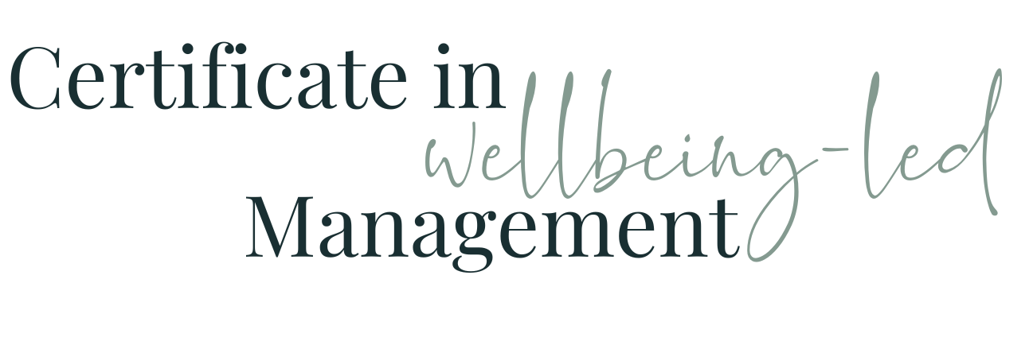

Module Twelve WORKBOOK

Module Twelve - Coaching & Mentoring

Task One - Your expertise
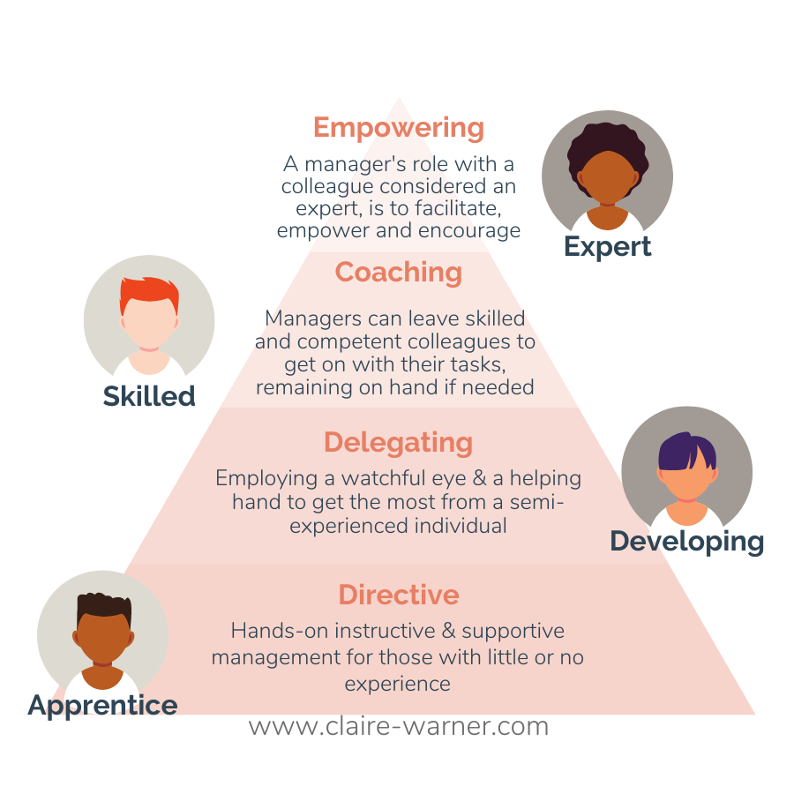
Using the 4 categories in the diagram above, honestly identify which areas of your current role you consider yourself to be in which of these categories of expertise

Apprentice

Developing

Skilled

Expert

Task Two - Past experience

When, if at all, have you benefited from coaching and / or mentoring skills being used by your Manager in their general day to day management of you ?

How did that make you feel / benefit you / what impact did it have?

When, if at all, have you benefited from specific periods of coaching and / or mentoring on a 1:1 basis either with a colleague or someone externally ?

How did that make you feel / benefit you / what impact did it have?

When, if at all, would you like to have benefitted from either of the above, what was the situation and how would it have helped?

Task Three - Current Situation

Where do you feel you could benefit now from a) coaching and / or mentoring skills being used by your Manager in their general day to day management of you; and b) specific periods of coaching and / or mentoring on a 1:1 basis either with a colleague or someone externally?

How would that make you feel / benefit you / what impact would it have?

Who / what type of person would be your ideal coach / mentor (for each scenario, if you have more than one)?

Task Four - You as a Manager

Where are you now going to include some of these elements in your day-to-day management of your team members?

How do you want to make them feel / benefit them / what impact would it have?

Task Five - Your Team

Where could members of your team benefit from specific coaching and / or mentoring on a 1:1 basis either with a colleague or someone externally ?

How do you want to make them feel / benefit them / what impact would it have?

How can you make this happen for them?

Task Six - Approaching this with them

Refer back to task one and use this link to provide each of your team members with the same diagram and 4-part question and ask them to fill it in - it would be really good practice, if you’re happy to do so, to share yours with them

Task Seven - Module Twelve Summary

What seem the most significant elements of this module to you as an individual?
What seem the most significant elements of this module to you as a manager?
What insights have you gained into the behaviours of your colleagues at work?
How will what you’ve learned help you in understanding and managing the members of your team?

Questions
What questions do I have from this module that I need to note down to ask?

