

Module Six WORKBOOK



Module Six

Task One - Current Situation
As you work through the workshop I’d like you to score yourself out of 5 (1 being poor, 5 being great) in terms of the extent to which you’re already doing each element and how well
Essence of Performance Management | Score
a holistic approach that encompasses goal-setting, continuous feedback, and professional development
involves creating an environment where individuals and teams can thrive despite geographical distances
Aligning individual contributions with organisational goals,
leveraging technology for seamless collaboration
ensuring that each team member feels supported and recognized
Integrating Performance Management
seamlessly woven into everyday practices
fostering a culture of continuous improvement, where performance discussions become a natural part of day-to-day interactions
integrate performance considerations into regular team meetings, project updates, and individual check-ins to ensure that performance is a living, breathing aspect of the team's dynamic
Proactive Performance Management
Rather than waiting for issues to arise and then reacting, we must proactively engage with our remote team colleagues
setting expectations clearly from the outset, providing the necessary tools and resources, and actively supporting team members in their roles
allows for timely recognition of achievements, early identification of challenges, and the swift implementation of solutions

Task Two - Performance Management Challenges
As you work through this section workshop I’d like you to give a score (1 being has little impact, 5 being has huge impact) in terms of the extent to each of these common challenges applies to your team

Score
Unclear Expectations
Inconsistent Feedback
Neglecting colleague development
The wrong measures
Lack of employee involvement
Feedback delays
Failure to address issues promptly
Ignoring individual differences
Objectives not aligned across organisation
Limited opportunities for casual feedback
Balancing accountability and autonomy
Impact of isolation on performance

Looking at the scores you’ve assigned above, are there any obvious a) major concerns you don’t know how to address; b) areas where you could make improvements fairly easily?

Task Three - Remote Management Framework

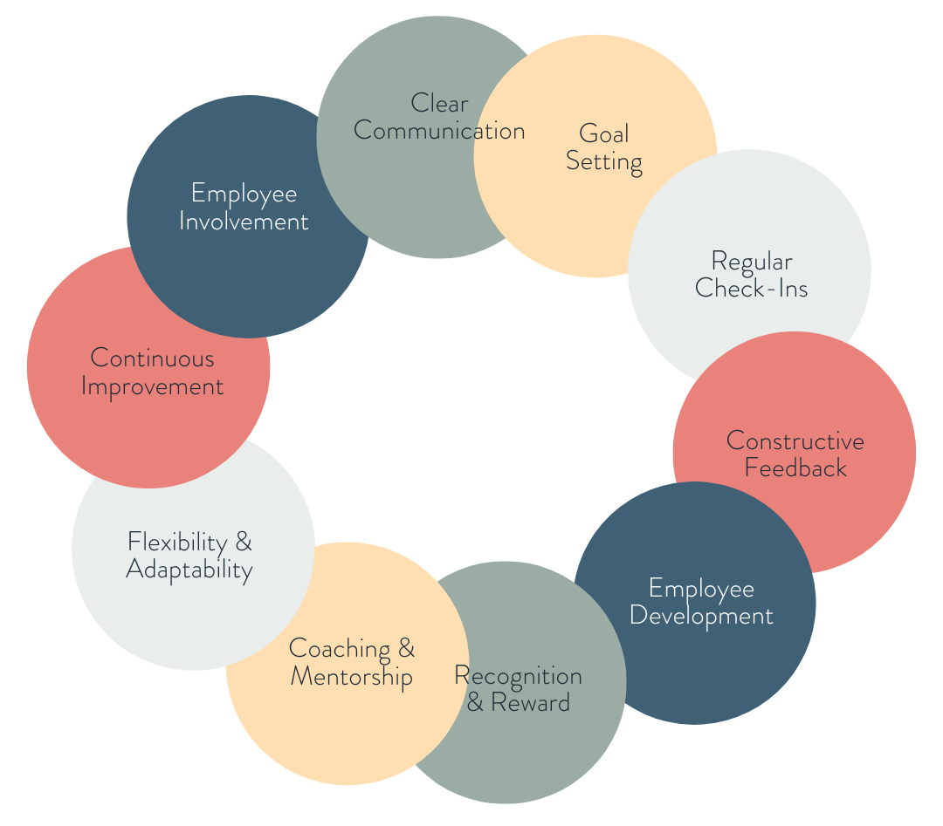

Ten Framework Elements:
Clear Communication; Goal Setting; Regular Check-Ins; Constructive Feedback; Employee Development; Recognition & Reward; Coaching & Mentorship; Flexibility & Adaptability; Continuous Improvement; Employee Involvement

Task Four - Performance Management Cycle

Month One - Goal Setting & Planning
Months Two to Five - Regular Check ins and Progress Monitoring
Month Four - Create 1/4ly work plan to achieve this quarter’s KPIs
Month Six - Mid Year Review
Month Seven - Create third 1/4ly work plan to achieve this quarter’s KPIs
Months Seven to Eleven - Continued check-ins and coaching
Month Ten - Create fourth 1/4ly work plan to achieve this quarter’s KPIs
Throughout the Year - Continuous learning & improvement

Performance Development & Management Plan Template
Use this template to think through the current members of your team, where you think you need to place focus, where and how, and how you’re going to plan embedding this work as part of your ongoing management relationship with them (Make a new copy for each colleague)

Colleague Name
Role
Key Responsibilities
Framework Area | Work that needs to be done | Priority
Clear Communication
Goal Setting
Regular Check-Ins;
Constructive Feedback
Employee Development;
Recognition & Reward;
Coaching & Mentorship;
Flexibility & Adaptability
Continuous Improvement;
Employee Involvement
Month | Performance Development and Management meetings, work and support that need including in calendar commitments

Module Four Summary

What seem the most significant elements of this module to you as an individual?
What seem the most significant elements of this module to you as a manager?
What insights have you gained into the behaviours of your colleagues at work?
How will what you’ve learned help you in understanding and managing the members of your team?

Questions

What questions do I have from this module that I need to note down to ask?

