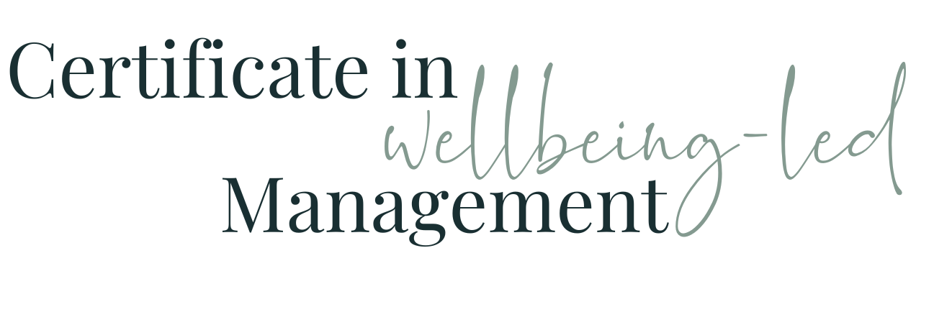

Module Eight WORKBOOK

Module Eight - Dealing with difficult people

Task One - Difficult behaviours

Which difficult behaviours do you know you deal with on a daily / weekly basis?

Task Two - Difficult people?

Who do you find difficult at work?

What is it about them you find difficult?

How have you tried to tackle it previously?

Task Three - Difficult or Different?

Having reconsidered the Myers Briggs / 16 Personalities information from Module three, how might you now see these people differently?

What is it about them you find DIFFERENT?

How how might you now use this perspective to work with them differently?

Task Four - The Types

1) The Ego has landed - Who?
What are you now going to try?

2) Nigel / Nigella Nice - Who?
What are you now going to try?

3) Colin / Connie Complainer - Who?
What are you now going to try?

4) Silent Simon / Simone - Who?
What are you now going to try?

5) Waffling Wendy / Indecisive Ian - Who?
What are you now going to try?

6) Pessimistic Peter / Penny - Who?
What are you now going to try?

Task Five - Self Awareness

What might you now need to consider about yourself and your own characteristics?
Who in particular might you need to change your approach or behaviours around?
How could you spread this self-awareness wider in your team?
How can you keep reminding yourself about difference rather than difficult?

Task Six - Module Eight Summary

What seem the most significant elements of this module to you as an individual?
What seem the most significant elements of this module to you as a manager?
What insights have you gained into the behaviours of your colleagues at work?
How will what you’ve learned help you in understanding and managing the members of your team?

Questions

What questions do I have from this module that I need to note down to ask?

