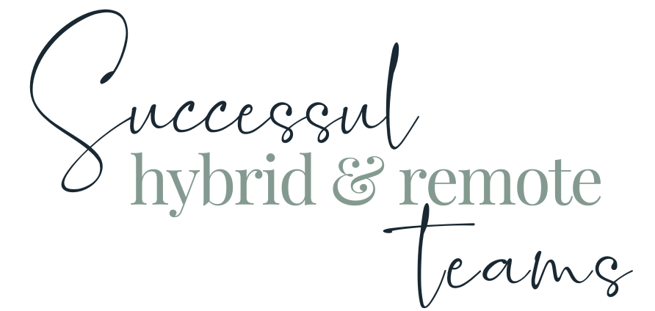

Module Two WORKBOOK



WELCOME

This workbook has been created to accompany the Successful Hybrid & Remote Teams programme

The workbook is designed to be worked through as you cover each module within the course. Each module has a video and a corresponding workbook section so that at the end of the course, you have one complete Successful Hybrid & Remote Teams personal learning handbook, if you will.

The videos in each module are created with the workbook in mind. There are multiple videos per module, usually we will ask a question from the workbook at the end of one video and in advance of the next. At points in the films, you are given the option to press pause and complete the relevant section, and then unpause and continue when you have finished. You don’t have to do the work like that, you can watch the whole video and then do the workbook, you can watch the video and ignore the workbook - it’s up to you.

The questions and themes contained within each module are designed to challenge your thinking. Some you will know straight away. Others, you will have to think about. And some, will unfortunately need to wait until you are actually approaching or even in the thick of the stress and challenge for you to be able to discover and iterate.

Module Two

Task One - Biggest Challenges
What are the biggest challenges or gaps in your teams ( remembering the different types of teams we identified in module one) around relationships and relationship culture that you want to improve in your team? You might have come up with more than a few. Now try to group these into challenge areas and identify the three most pressing or significant.
Challenge area one
Challenge area two
Challenge area three

Task Two - Ideal world

In an ideal world, how would you start to address these with your colleagues?
Challenge area one
Challenge area two
Challenge area three

What’s currently stopping you or holding you back from doing this?
Challenge area one
Challenge area two
Challenge area three

Task Three - Relationships - basics

Does your a) team b) organisation have an up-to-date “who’s who” of who everyone is, their working pattern and location, and what they do?
a)
b)
How could this be improved?

Does your a) team b) organisation use anything like our You-ser Manual (see downloads section) to help colleagues build better relationships
a)
b)
How could this be improved?

Does your a) team b) organisation operate a buddy system to match people who are experiencing similar change (joining org, moving roles, returning to work etc) with someone who has recently made the same change?
a)
b)
How could this be improved?

Does your a) team b) organisation deliberately assign work that two or more people need to complete and achieve collaboratively rather than in isolation?
a)
b)
How could this be improved?

Task Four - Belonging
If an intrinsic part of Belonging is “feeling genuine connection and being valued for who you are”;

a) what are the main challenges or problems with this you currently face or can see in your teams?
b) what would you like to improve first?

Looking at the areas you’ve identified in A, identify which of them might be helped or ‘lifted’ by”

Creating an Employee Resource Group - where employees who share a common identity, share same situations, facing similar challenges can build community, connect and collaborate
Establishing Norms - Create guidelines for inclusive behavior and communication.
Encourage team members to actively contribute to shaping these norms
Implementing Check-Ins (between your colleagues as well as between you and them) Holding regular check-ins beyond project discussions. Use these meetings to discuss personal experiences, challenges, and successes
Watercooler Opportunities - creating informal channels or platforms for casual conversations.
Encourage team members to share non-work-related updates to foster a sense of camaraderie

Task Five - Trust
If Trust helps us feel safe and and safe to ‘belong’, and creates the currency that fuels collaboration and teamwork,

a) what are the main challenges or problems with this you currently face or can see in your teams?
b) what would you like to improve first?

Looking at the areas you’ve identified in A, identify which of them might be helped or ‘lifted’ by”

Transparent Communication - establishing clear communication channels and guidelines; using platforms that facilitate transparent communication (project management tools and collaboration platforms)
Being Reliable - ensure commitments made are consistently followed through; and addressing delays or challenges promptly and transparently
Keeping Confidences - acknowledge the trust placed in you when someone shares something personal, vulnerable or private don’t engage in office gossip or tittle-tattle - show you keep confidences

Task Six - Openness
If Openness helps us feel the permission to feel safe - that we are able to bring our whole selves to work and that also show they do this and so we can be open and “us”, then

a) what are the main challenges or problems with this you currently face or can see in your teams?
b) what would you like to improve first?

Looking at the areas you’ve identified in A, identify which of them might be helped or ‘lifted’ by”

Inclusive Introductions - introducing yourself by your name, what you do, your pronouns, and a brief physical description, and encouraging others to do the same
Showing Vulnerability - Share what you find difficult or that you are feeling overwhelmed or overloaded; and encourage and empower others to do the same
Share Compassion - Share when you’re struggling (non-work task related) and what you need (if you know) and encourage and empower others to do the same

Task Seven - Culture

Designed / Defined Culture

Does your a) team b) organisation have a stated “way we do things around here?
a)
b)
How could this be introduced / improved?

“The way we do things”

What are they / What do you want them to be?
What are they not? / What do you not want them to be?
How do you hold each other accountable / want to hold each other accountable?
What can YOU do to influence improvement in these?

Internal Values / Internal Reflection of External Values

What are they / What do you want them to be?
How do you want to see these lived in your team / organisation?
What can YOU do to influence improvement in these?

Inclusive

Is everyone included in defining and creating culture? How could they be included?
What can YOU do to influence these?

Safety

Do colleagues feel safe to share when they’re struggling; when there are things they don’t know; when there are things YOU can change that would help them?
What can YOU do to influence improvement in these?

Modelling Behaviour

Do you feel you model the behaviour(s) you want to see in others?
What can YOU do to improve this?

The ripples

Where could you start to improve some of these?
How can you share the ‘ripples’ of these improvements so that the rising tide lifts other (and then all) boats?

Module Two Summary

What seem the most significant elements of this module to you as an individual?
What seem the most significant elements of this module to you as a manager?
What insights have you gained into the behaviours of your colleagues at work?
How will what you’ve learned help you in understanding and managing the members of your team?

Questions

What questions do I have from this module that I need to note down to ask?

