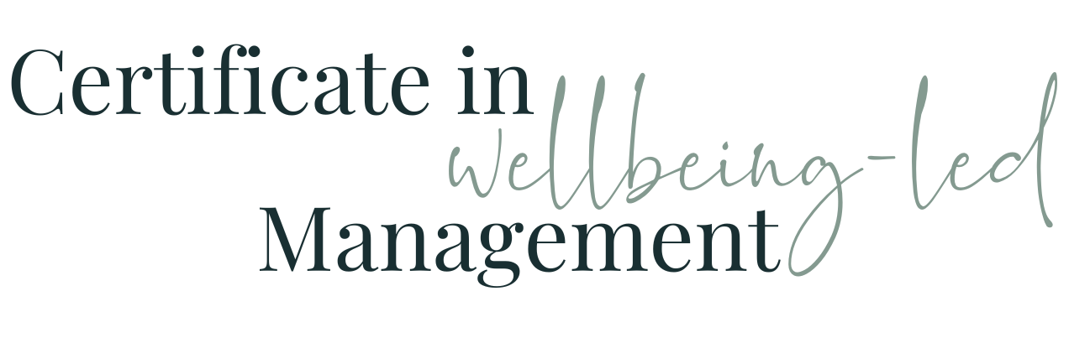

Module Eleven WORKBOOK

Module Eleven - Influence & Influencing

Task One - Influence

Where do you think you have tried to use influence before?

How well did it work?

What can you learn from that?

Task Two - Reciprocity

What situations can you think of where you could use reciprocity as part of your approach?

Which colleagues can you see you might be able to improve relationships with by the use of reciprocity in the future?

Task Three - Commitment

What situations can you think of where you could use commitment as part of your approach?

Which colleagues can you see you might be able to improve relationships with by the use of commitment in the future?

Task Four - Authority

What areas can you think of where you could identify and exert your own expertise and knowledge and therefore grow your own authority?

Where might this help you?

What areas can you think of where you could help members of your team to identify and exert their own expertise and knowledge and therefore grow their own authority?

Where might this help them?

Task Five - Rapport

What situations can you think of where you could use rapport as part of your approach?

Which colleagues in particular can you see you might want to improve relationships with and what areas of rapport and shared experience and similarity can you identify to start that relationship building with?

Task Six - Social Proof

What situations can you think of where you could use social proof as part of your approach?

Whose actions do you need to be able to highlight and share in order to get who to “copy” them? Who do you want to influence and whose actions will they be impressed / persuaded by?

Task Seven - Scarcity

What situations can you think of where you could use scarcity as part of your approach?

Which colleagues can you see you might be able to improve influence by the use of scarcity now or in the future and how could you do this?

Task Eight - Unity

What situations can you think of where you could use unity as part of your approach?

Which colleagues can you see you might be able to influence by the use of unity or which colleagues you could benefit from unity with, and how?

Task Nine - Your current situation

Below, list some of the people-based challenges you face, what the challenge is, who you need to be able to influence to improve the situation, which of the principles of influence you think would help, and which influencing skills you will need to adopt to maximist success

Person One
Name
Plan
Person Two
Name
Plan

Person Three
Name
Plan

Task Ten - Module Eleven Summary

What seem the most significant elements of this module to you as an individual?
What seem the most significant elements of this module to you as a manager?
What insights have you gained into the behaviours of your colleagues at work?
How will what you’ve learned help you in understanding and managing the members of your team?

Questions
What questions do I have from this module that I need to note down to ask?

