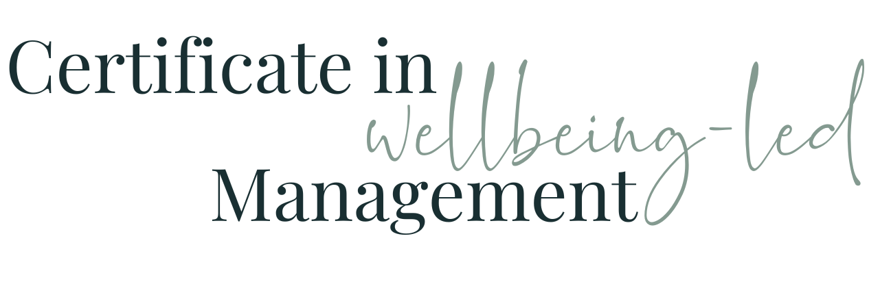

Module Two WORKBOOK

Module Two - the Elements of great management

Element One - Knowing What’s Expected
Make your answers as extensive as you can - answer the question and give the detail. If you need to, answer multiple times for multiple colleagues (box will grow as you type)
Do you know what is expected of you and your team?
Is that a consistent message you’re receiving or do those expectations change?
Do you know where these fit in with the overall organisation expectations?
Are these the things you’re measured on (your KPIs)?
Do the individuals in your team know what is expected of them?
Is that a consistent message they’re receiving or do those expectations change?
Do they know where those fit in with the overall team expectations?
Do they know where those fit in with the overall organisation expectations?
Are these the things they’re measured on (their KPIs)?
If you’ve answered “no” to any of the elements above, how could you 1) make it a little bit better and 2) solve it completely

Element Two - Materials and Equipment

Do you have the tools, tech, materials and equipment you need to do your job?
Do you have access to the information you need to do your job?
Do the members of your team have the tools, tech, materials and equipment they need to do their jobs?
Do they have access to the information they need to do their jobs?
What distractions and / or challenges can you remove for yourself?
What distractions and / or challenges can you remove for the members of your team?
When did your Manager last ask you “what do you need?”
When did you last ask each member of your team “what do you need?”
How could you make improvements in this area?

Element Three - At work, I have the opportunity to do what I do best every day

Do you know which bits of your role you’re best at?
How could you structure your day so that you could do a bit of that every day?
Do the members of your team each know which bits of their roles they’re best at?
How could you structure their days so that they could do a bit of that every day?
Do you know which bits of your role you’re not best at?
How could you use this new structure to your day to help you improve the bits you’re not so good at?
Do your team know which bits of their roles they’re not best at?
How could they use this new structure to their days to help them improve the bits they’re not so good at?
If it’s more to do with not liking bits rather than not being good at them, how could you use the structure of your day to use the other bits as a reward or to just get through the disliked bits as quickly and efficiently as possible?
If it’s more to do with not liking bits rather than not being good at them, how could your team use the structure of their days to use the other bits as a reward or to just get through the disliked bits as quickly and efficiently as possible?
What opportunities are there for incremental beneficial change? To make small improvements to your / their abilities? To make small incremental changes to how much you / they dislike something ?

Element Four - In the last 7 days, I have received recognition or praise for doing good work

Does your boss always / usually take notice of and retain information you’ve shared with them about what you and your team are doing? Or do they ask for information and then tell others they don’t know the answer to the question?
How does that make you feel?
Do you always / usually take notice of and retain information your team have shared with you about what they’re doing? Or do you ask for information and then tell others you don’t know the answer to the question?
How do you think that makes them feel?
Have you received recognition or praise for doing good work in the last 7 days?
If so, for what, and how did it make you feel?
If not, what could / should you have received recognition for, and how did it make you feel to not get it?
Have you given recognition or praise to your team members for doing good work in the last 7 days?
If so, for what, and how did it make you and them feel?
If not, what could / should you have recognised and praised, and how does it make you feel having not delivered it?
Are there some areas / people you tend to forget?
How could you make improvements in this area?

Element Five - My Supervisor or someone at work seems to care about me as a person

Do you feel that your boss or someone at your work seems to care about you as a person?
How do they show that?
Do you (or someone else) at your work, care about the members of your team as people??
How do you show that?
Do you feel that your boss or someone at your work has shown an interest in how you have been and how you are during the pandemic?
How did they show that?
Have you or someone at your work shown an interest in how your team have been and how they are during the pandemic?
How have they been shown that?
How comfortable would you be in approaching / sharing with your boss about something in your life outside work?
How could they make you more comfortable?
How comfortable would the members of your team be in approaching / sharing with you about something in their lives outside work?
How could you make them more comfortable?

Element Six - There is someone at work who encourages my development

Do you feel that your boss or someone at your work encourages your development?
How do they do that?
Do you (or someone else) at your work, encourage the development of the members of your team??
How do you do that?
Do you feel that there is a future for you within your organisation beyond the current scope and responsibility of your role?
If so. Why? If not, Why not?
Do your team members feel that there is a future for them within your organisation beyond the current scope and responsibility of their roles?
If so, how and why? If not, Why not?
How could you improve this?

Element Seven - At work, my opinion counts

Do you feel that your opinion counts at work?
If so, how, and how does it make you feel? If not, why do you, and how does that make you feel?
Who at work knows about your role and your part in the whole better than you?
Do you give the members of your team the opportunity to express their opinions and for those opinions to count?
If so, how do you do that and if not, why not?
Who at work knows about their roles and their parts in the whole better than them?
If so. Why? If not, Why not?
How else could you ask / not assume / seek the opinions of ALL of your team about how things could be better / quicker / bigger / for more people etc?
How could you ALL benefit from some of that

Element Eight - The mission or purpose of my employer makes me feel my job is important

Do you feel your job plays an important part in delivering the purpose of your organisation?
Why / Why Not?
Do all of the members of your team feel their jobs play an important part in delivering the purpose of your organisation?
Why / Why Not
Which of the cogs in the machinery of your organisation could you do without?
Who in your team would describe themself/ves as “only a…”
How could you help improve their sense of value and contribution?

Element Nine - My associates or fellow employees are committed to doing quality work

Do you feel all of your colleagues are as committed as each other to the delivering of your organisation’s purpose
If not, who isn’t and how does that behaviour / performance manifest through the team / organisation?
How could that be changed?
Do all of the members of your team feel that all of their colleagues are as committed as each other to the delivering of your organisation’s purpose?
If not, who isn’t and how does that behaviour / performance manifest through the team / organisation?
How could that be changed?
What has stopped you from addressing that thus far?

Element Ten - I have a best friend at work

Do you have a work best friend?
If not now, have you ever?
Who is there that you can talk to about the challenges and joys of your role, that understands the context as well as the content?
How can you “sell” the notion to your colleagues?
How can you foster the development of these relationships for your team members?

Element Eleven - In the last 6 months, someone at work has talked to me about my progress

Has your boss talked to you about your progress in the last 6 months?
How has that made you feel?
Have you talked to each of your team members about their progress in the last 6 months?
How do you think that has made them feel?
How comfortable are you in having those conversations?
Are there any conversations you are avoiding?
How could this be improved?

Element Twelve - In the last 12 months at work, I have had the opportunities to learn and grow

Have you been given opportunities within the last 12 months to learn and grow?
How has that made you feel?
Have you given each of your team members opportunities within the last 12 months to learn and grow?
How do you think that has made them feel?
What could you do to increase or instigate those opportunities?
What are the barriers currently
How could this be improved?

Element Thirteen - My Manager shows a genuine interest in being a great manager

Does your line manager?
How can you tell?
How does that make you feel?
Does you?
How can your team tell?
How do you think that makes them feel?

Module Two Summary

What seem the most significant elements of this module to you as an individual?
What seem the most significant elements of this module to you as a manager?
What insights have you gained into the behaviours of your colleagues at work?
How will what you’ve learned help you in understanding and managing the members of your team?

Questions

What questions do I have from this module that I need to note down to ask?

