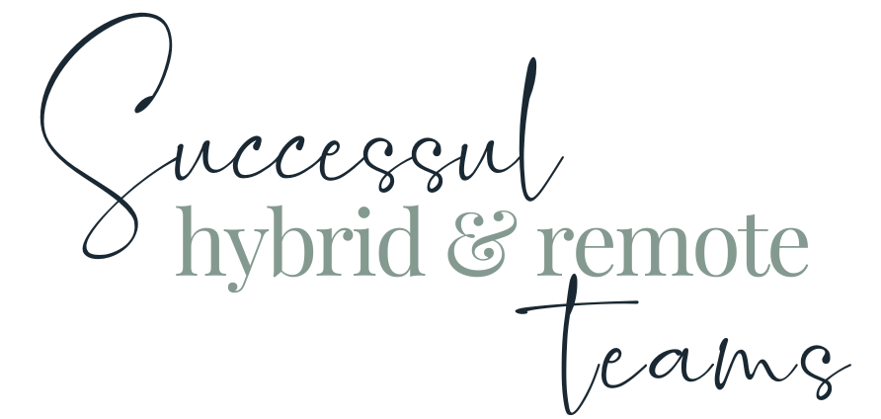

Module One WORKBOOK

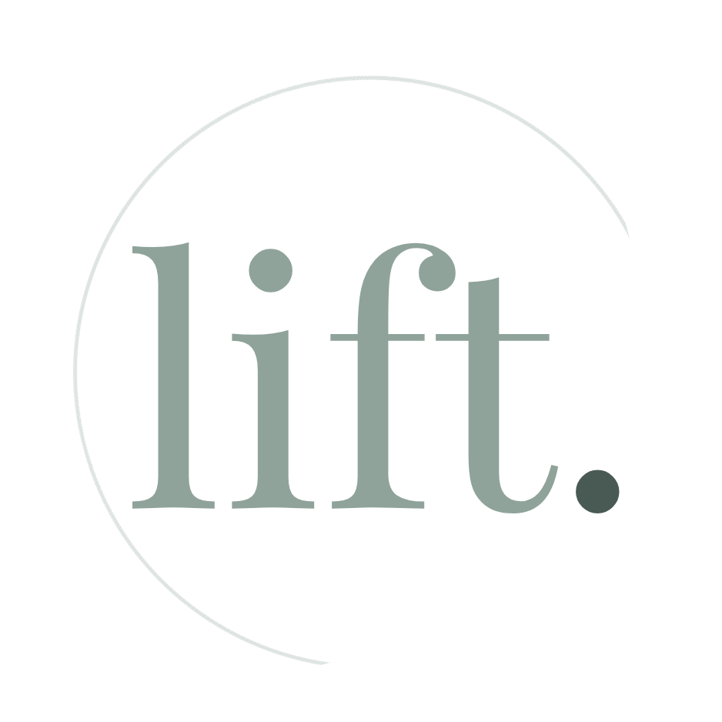

WELCOME

This workbook has been created to accompany the Successful Hybrid & Remote Teams programme

The workbook is designed to be worked through as you cover each module within the course. Each module has a video and a corresponding workbook section so that at the end of the course, you have one complete Successful Hybrid & Remote Teams personal learning handbook, if you will.

The videos in each module are created with the workbook in mind. There are multiple videos per module, usually we will ask a question from the workbook at the end of one video and in advance of the next. At points in the films, you are given the option to press pause and complete the relevant section, and then unpause and continue when you have finished. You don’t have to do the work like that, you can watch the whole video and then do the workbook, you can watch the video and ignore the workbook - it’s up to you.

The questions and themes contained within each module are designed to challenge your thinking. Some you will know straight away. Others, you will have to think about. And some, will unfortunately need to wait until you are actually approaching or even in the thick of the stress and challenge for you to be able to discover and iterate.

Module One

Task One - Team
Who are the people you have a 1:1 manager, managee ‘team’ relationship with?
Who are the people you are in a traditional, subject-area team with?
Who are the people you are in a peer manager level team with?
Who are the people you are in a workflow team with?
Before this exercise, how many of these would you have considered to be in your ‘team’?

Task Two - Biggest Challenges
what the biggest challenges are around team cohesion, success etc, that you want to improve in your team? You might have come up with more than a few. Now try to group these into challenge areas and identify the three most pressing or significant.
Challenge area one
Challenge area two
Challenge area three

Task Three - Success needs of colleagues as team contributors
For each of these elements we’d like you to think about
- Do i) you, ii) your team members, iii) colleagues outside your team get / feel these?
- How could this be improved for i) you, ii) your team members, iii) colleagues outside your team

1) Clear Expectations

Do they know what they’re supposed to do, how they’re supposed to do it, and what ‘good’ looks like?
a)
b)

2a) Materials & Equipment

Do they have the materials, the tools, the equipment, the “stuff” to deliver those expectations and to deliver them well?
a)
b)

2b) Information

Do they have access to the information they need to deliver those expectations and to deliver them well?
a)
b)

3) Development Opportunities

Do they have opportunities to learn and grow in their role?
a)
b)

4) Regular Feedback

Do they receive regular feedback? Are they aware of their strengths and areas for improvement?
a)
b)

5) Recognition & Praise

Do they regularly receive praise? Weekly? Not focused on improvement but on motivation? Genuine? Inclusive?
a)
b)

6) Care & Respect

Do they feel cared about as a person? Do they feel respected and treated with respect??
a)
b)

7) Coaching & Development

Are they provided with development opportunities? Are they coached to help them achieve these and grow?
a)
b)

8) Purpose

Can colleagues see where their role aligns with the organisation’s purpose and contributes to its work and the achieving of its goals?
a)
b)

9) Quality of work

Do colleagues feel that their colleagues are committed to delivering great quality work as much as they are?
a)
b)

10) Wellbeing & Balance

Do colleagues feel that their wellbeing and work / life balance are considered and supported?
a)
b)

Task Four - Success needs of Teams (as a collective group)
For each of these elements we’d like you to:
a) think about to what extend these exist / are felt in your team and rank them 1 - 5 (one being the lowest score and five being the highest score
b) suggest how they could be improved

1) Clear goals & objectives

Do colleagues have a shared understanding of the Team goals and objectives
AND where their individual goals and objectives contribute and ‘meet-up’ to achieve for the Team (Check on overlap & gaps!)
a)
b)

2) Strong Leadership

Do colleagues have Managers and Leaders who have defined a clear vision and who provide direction, guidance, coaching and support. Do those Managers & Leaders allow stream or flow leaders to emerge and flourish
a)
b)

3) Diverse Skill Sets

Do colleagues have diverse work backgrounds, skills, knowledge and experience?
a)
b)

4) Effective Communication

Do colleagues communicate well? Team? Workflow? Do they listen as well as share?
Do they share ideas, information and feedback? Are these shared around the organisation, not just in the Team? Is this done openly and constructively?
a)
b)

5) Trust & Collaboration

Do colleagues trust each other? Do they trust each other’s abilities, intentions, reliability, confidentiality? Do they feel trusted? Can they use this trust, along with the other elements, to collaborate well?
a)
b)

6) Accountability

Do colleagues have ownership of their work? Do they feel accountable for their individual contributions and outcomes? Does everyone play their part?
a)
b)

7) Problem Solving

Are colleagues able to move quickly from acknowledging a problem or challenge, to problem-solving? Can they be creative? Do they work together to find solutions? Do they have the agency to come up with ideas?
a)
b)

8) Adaptability

Are colleagues flexible? Can they adapt to changing priorities? Can they still see the direction of travel? Can they move forwards and change approach quickly?
a)
b)

9) Support & Resources

Do colleagues have the Materials, Equipment, Tools, and Information they need AND Do they also get the support, training, coaching, wider understanding they need?
a)
b)

10) Continuous Improvement

Is there a Culture of continuous ‘lifting’, evaluating, learning, repeat? Not stuck in perfectionism? They don’t just stick with “a solution” but work towards “the solution:
a)
b)

11) Conflict Resolution

Do they have conflicts / disagreements? - Good! Are the structures or mechanisms in place to address and resolve constructively
a)
b)

12) Celebrate Achievements

Do they celebrate Individual Achievements? Team Achievements? And do they also
failures and learning?
a)
b)

13) Shared Values & Norms

Do you have Team Values? Do you have an agreed a set of “norms” in terms of ‘the way things are done’:
a)
b)

14) Emotional Intelligence

Are your colleagues self-aware? Are they able to understand and manage their own feelings and emotions? Are they able to understand and empathise with the feelings and emotions of others?
a)
b)

15) Innovative & Creative

Does your team encourage a culture of innovation and creativity? Are those who are more inclined to this area able to use their strengths regularly?
a)
b)

16) Well-defined processes

Does your team (and your organisation!) have clear, well-defined processes? Do all processes work for everyone? Does everyone have access to them?
Well defined processes make creativity & innovation possible
a)
b)

Task Five - Workplace application of Maslow’s Hierarchy of Needs - our workplace needs as Humans
For each of these elements we’d like you to:
a) think about to what extend these exist / are offered fir your team and rank them 1 - 5 (one being the lowest score and five being the highest score
b) suggest how they could be improved

1) Psychological Needs

Access to basic necessities - Fair Pay, Fair Conditions, Safe work environment, Adequate Breaks etc
a)
b)

2) Safety Needs

E.G Job security, transparency, treated well, wellbeing prioritised
a)
b)

3) Belonging Needs

Strong social connections; Feel “part” of a team; Feel someone cares about them as a person; Sense of community & Support; Feel valued - they matter
a)
b)

4) Esteem Needs

Recognition and appreciation
Acknowledge contributions (of everyone)
Opportunities for skill development and growth
a)
b)

5) Self Actualisation Needs

Empowered to pursue their career passions; Empowered to pursue their career goals; Supported to do so in your organisation; Uplifted and ‘released’ with your blessing
a)
b)

Module One Summary

What seem the most significant elements of this module to you as an individual?
What seem the most significant elements of this module to you as a manager?
What insights have you gained into the behaviours of your colleagues at work?
How will what you’ve learned help you in understanding and managing the members of your team?

Questions

What questions do I have from this module that I need to note down to ask?

