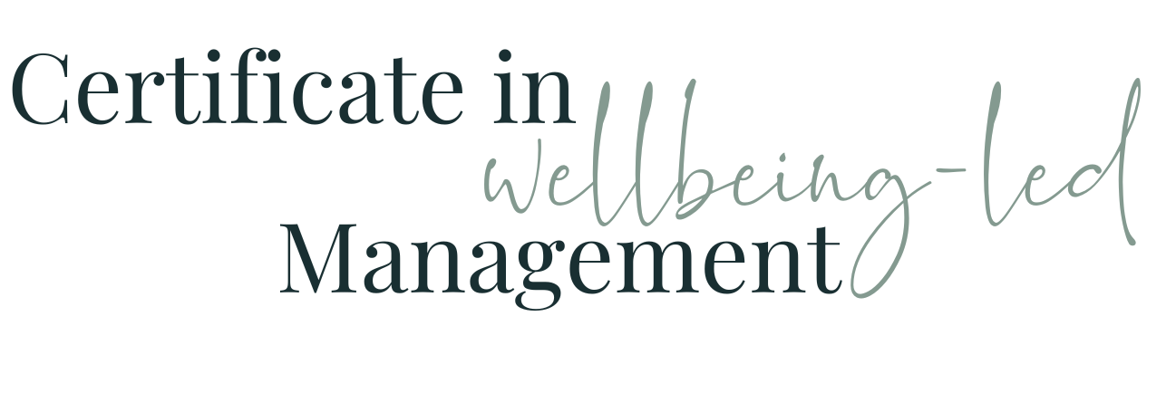

Module Nine WORKBOOK

Module Nine - Challenging Conversations

Task One - Past Conversations

Think of an example of a past conversation you wish you’d handled differently

Who was it with and what do you now know about their work character, their approach, their motivations and their comfort zones?

What was the desired outcome of the conversation?

What was the actual outcome of the conversation?

If you were holding the conversation again now, what preparation would you do?

What is the reaction you expected / would expect from the person?

Why do they react like that / expect that?

How could you mitigate against that / hold your ground and your authority?

What would you do now to get the conclusion you want?

Which bit worries you most / are you most nervous about

Task Two - Preparation

What is the purpose of the conversation?

What relevant information do you need to gather?

What do you need to consider about the other person’s perspective?
When / where will be the right place to hold this conversation?
What does the agenda of the conversation need to be?
What emotional reactions (yours and theirs) do you need to anticipate?
Where can you exercise and practice empathy to prepare for this conversation?
What Active Listening techniques are you going to use and how will you ensure you do so?
What suggested solutions are you going to bring to the table? How will you suggest these and engage the other person in ownership of these?
Where and How might you need to keep your own emotions in check?
What next steps are you going to create and how will you offer these?
What are the potential outcomes and how will you be sharing these?
What support are you going to offer?
When and how are you going to follow up?

Task Three - Executing the Conversation

How will you open the conversation and set the tone?
How will you explain the purpose of the conversation?
Which ‘I” statements are you going to use?
How are you going to address behaviours rather than personality?
How are you going to address emotions?
How are you going to engage in collaborative problem solving?
What do you hope the next steps are going to be and how will you agree these?
How are you going to close the conversation?

Task Four - Follow-Up

What post-conversation support are you going to provide and how?
What follow-up tools and strategies are you going to use?
How are you going to use this conversation as a continuous learning opportunity?

Task Five Future Conversations

Think of an example of a conversation you know you need to have and have been putting off

Who was it with and what do you now know about their work character, their approach, their motivations and their comfort zones?

What are the desired outcome of the conversation?

What has been stopping you from holding it?

If you were holding the conversation next week, how would you now prepare for it?

What is the reaction you expect from the person?

Why do you think they will react like that?

How can you mitigate against that / hold your ground and your authority?

What do you need to do to get the conclusion you want?

Which bit worries you most / are you most nervous about

Task Six - Changes I need to make to my mindset

What do I need to change about the way I approach these types of conversation?
What persona do I need to adopt to get the outcome I want?
What is the biggest change that needs to take place to make that happen?
How can I make this comfortable / less uncomfortable?

Task Seven - Module Nine Summary

What seem the most significant elements of this module to you as an individual?
What seem the most significant elements of this module to you as a manager?
What insights have you gained into the behaviours of your colleagues at work?
How will what you’ve learned help you in understanding and managing the members of your team?

Questions
What questions do I have from this module that I need to note down to ask?

