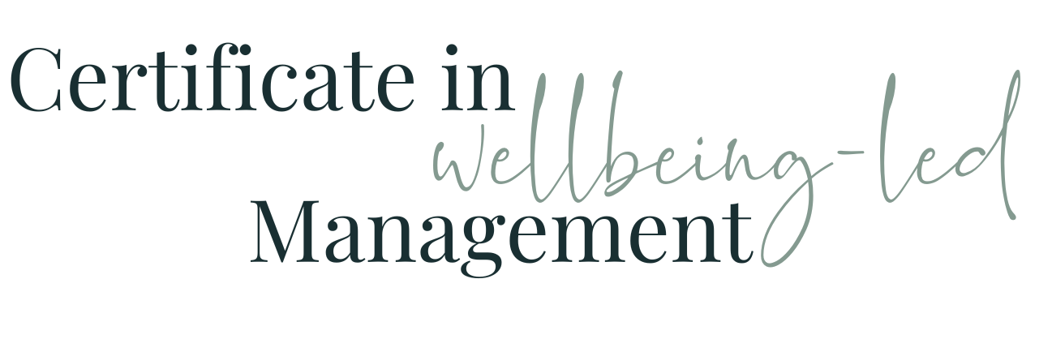

Module Three WORKBOOK

Module Three

Task One - Me

What do you know about yourself and your own characteristics?

Task Two - My Team - what I know already
What do you know about the work history of the members of your team? (fill in one box for each member - right click in the white box and choose insert row below to add enough rows for each person )
What do you know about the outside-work lives of the members of your team? (fill in one box for each member - right click in the white box and choose insert row below to add enough rows for each person )
What do you know about how each of the members of your team like to work? (fill in one box for each member - right click in the white box and choose insert row below to add enough rows for each person )
What do you know about the characteristics of each of the members of your team? (fill in one box for each member - right click in the white box and choose insert row below to add enough rows for each person )

Task Three - Personalities and Characteristics
https://www.16personalities.com/free-personality-test

Copy and paste the descriptor for your personality type and your %s below

The sixteen personalities

https://www.16personalities.com/personality-types

Task Four - The Five Types
Introvert or Extrovert? Put yourself and where you suspect your team and your boss fall, in each boss
Introvert
Extrovert

Sense or Intuition? Put yourself and where you suspect your team and your boss fall, in each boss
Sense
Intuition

Thinking or Feeling? Put yourself and where you suspect your team and your boss fall, in each boss
Thinking
Feeling

Judging or Prospecting? Put yourself and where you suspect your team and your boss fall, in each boss
Judging
Prospecting

Assertive or Turbulent? Put yourself and where you suspect your team and your boss fall, in each boss
Assertive
Turbulent

Task Five - What does this mean?

What do you notice about the combination of your work personality and each of the personalities of those you manage?

Who are you similar to?
What might that suggest about how they need to be managed?
Who are you opposite to?
What might that suggest about how they need to be managed?

What do you notice about the combination of the work personalities across your team?

Who are similar?
What might that suggest about how they will interact?
Who are opposites?
What might that suggest about how they will interact?

What do you notice about the incidence of each personality within your team?

What type have you got more than one of?
What type have you not got any of?
What might that mean to the way your team instinctively works?
What might that mean for areas where you know extra focus might be needed?

What do you notice about the combination of your work personality and that of your boss?

Are you similar?
What might that suggest about how you could manage upwards?

How does your indicative personality impact how you instinctively manage?

Things in your comfort zone

What does that tell you about what might be your areas of less comfort / your potential blind spots?

Things not in your comfort zone / your potential blind spots

Task Six - Module Three Summary

What seem the most significant elements of this module to you as an individual?
What seem the most significant elements of this module to you as a manager?
What insights have you gained into the behaviours of your colleagues at work?
How will what you’ve learned help you in understanding and managing the members of your team?

Questions

What questions do I have from this module that I need to note down to ask?

