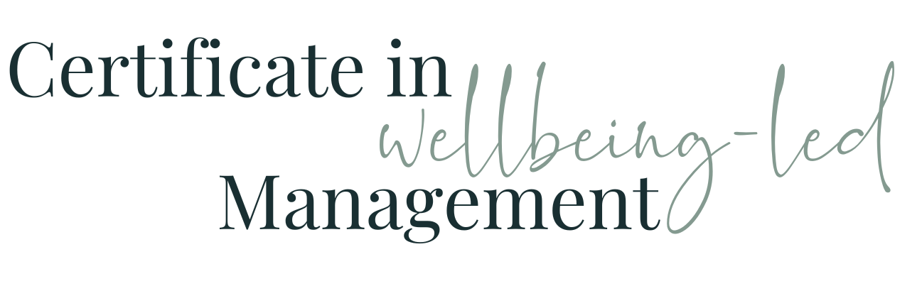

Module Seven WORKBOOK

Module Seven - Team Wellbeing & Mental Health

Task One - On a scale of 1 - 10 (1 being bad, 10 being great) how well would you rate your workplace...

Social Wellbeing
Psychological Wellbeing
Physical Wellbeing
Career Wellbeing
Community Wellbeing
Financial Wellbeing

Task Two - Your TeamHow comfortable would you be in asking these same questions of your team?

How comfortable would you be in asking these same questions of your team?

Task Three - Using what you know already, what might you be able to do / effect that could improve your wellbeing and your team’s wellbeing in the areas of

Social Wellbeing
Psychological Wellbeing
Physical Wellbeing
Career Wellbeing
Community Wellbeing
Financial Wellbeing

Task Four - Team Wellbeing Commitment

Checking In
Buddy
Team-designed wellbeing plan
Agreed team values
Flexibility
Openness around mental health
Co-working and relationship building opportunities
Opportunities for development and growth

Task Five - Common Causes - What impact do these have on YOU currently (1 - no impact, 10 - Huge)
Workload
Lack of Support
Bullying
Constant Change
Working while ill

Task Six - Common Causes - What impact would you estimate these have on your team currently (1 - no impact, 10 - Huge)
Workload
Lack of Support
Bullying
Constant Change
Working while ill

Task Seven - Suggestions. How feasible are each of these and if so, how could you make each of these possible
Stress Risk Assessment
Audit practices, policies and systems to ensure environment protects rather than impacts on wellbeing
Train team to spot signs of stress in themselves and each other
Promote flexible working options
Encourage regular and open communication
Encourage self-awareness
Communicate Well
Hold Wellbeing sessions

Task Eight - Mental Health - Awareness
Are you aware of any members of your team who have any mental health diagnoses or worries
If yes, how comfortable are you with being able to support them?

Task Nine - pro-active, how could you introduce the following within your team?
Checking In - Who, when, how often?
Buddy - if not you, who?
Spotting the difference between a slump and a pattern
Encouraging openness, lack of stigma, transparency and a commitment to prevention
Model - share your own slumps and blips
Use of the feelings wheel to help describe feelings

Task Ten - Wider Organisation
Does your wider organisation have a mental health or wellbeing policy?

If you don’t already have them, how could you introduce the ideas of:
Mental Health First Aiders
Employee Assistance Programmes
Signposting
Intervention policy

Task Eleven - Module Seven Summary

What seem the most significant elements of this module to you as an individual?
What seem the most significant elements of this module to you as a manager?
What insights have you gained into the behaviours of your colleagues at work?
How will what you’ve learned help you in understanding and managing the members of your team?

Questions

What questions do I have from this module that I need to note down to ask?

