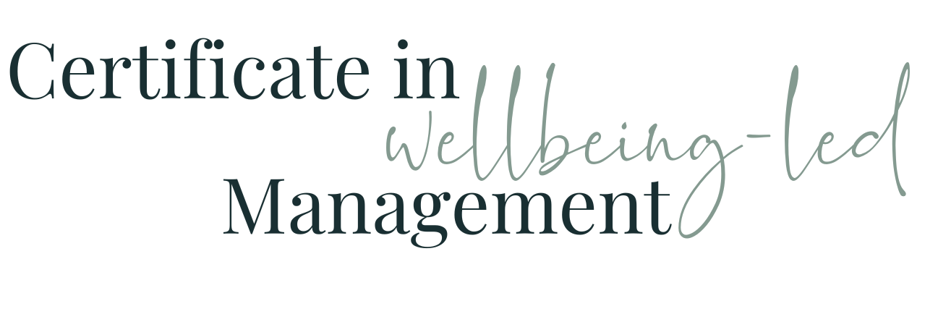

Module Ten WORKBOOK

Module Ten - Managing Performance

Task One - Status Quo

How do you manage performance currently?

How do you feel about it?

How is your performance managed?

How do you feel about it?

Task Two - Your team members

Name
What do you know you need to do specifically for this person in terms of their performance development?

Name
What do you know you need to do specifically for this person in terms of their performance development?

Name
What do you know you need to do specifically for this person in terms of their performance development?

Task Three - Your performance development

Which bits would you like to use to influence your boss’s performance development of you?

Task Four - Your future development

Which bits of performance do you recognise might not be applicable now but you know you want to hold on to for the future?

Task Five - Module Ten Summary

What seem the most significant elements of this module to you as an individual?
What seem the most significant elements of this module to you as a manager?
What insights have you gained into the behaviours of your colleagues at work?
How will what you’ve learned help you in understanding and managing the members of your team?

Questions
What questions do I have from this module that I need to note down to ask?

